Exercise 1: Logging Error Messages and Warning Levels
This exercise walks through setting up a small Java application in IntelliJ IDEA that uses SLF4J (with Logback as the logging backend) to print an error message and a warning message to the console.

Objective
Write a Java application that demonstrates logging at the ERROR and WARN levels using the SLF4J logging API.

Project Setup
The project was created as a plain IntelliJ IDEA project and then converted into a Maven project so that the SLF4J and Logback dependencies could be managed automatically. The steps below describe exactly how it was built.
- A new file named pom.xml was added at the root of the project so IntelliJ would recognize it as a Maven project.
- The SLF4J API and Logback Classic dependencies were declared inside pom.xml.
- IntelliJ prompted to load the Maven project, and after accepting, the dependencies were downloaded automatically.
- The standard Maven folder structure (src/main/java and src/main/resources) was created.
- A Java class named LoggingExample was added inside src/main/java, containing the logging calls.
- An optional logback.xml file was placed in src/main/resources to control the format of the console output.
- The class was run, and the console output was verified.

pom.xml
The dependencies added to the Maven configuration file:
<project xmlns="http://maven.apache.org/POM/4.0.0">
<modelVersion>4.0.0</modelVersion>

<groupId>com.example</groupId>
<artifactId>logging-exercise</artifactId>
<version>1.0</version>

<properties>
<maven.compiler.source>17</maven.compiler.source>
<maven.compiler.target>17</maven.compiler.target>
</properties>

<dependencies>
<dependency>
<groupId>org.slf4j</groupId>
<artifactId>slf4j-api</artifactId>
<version>1.7.30</version>
</dependency>
<dependency>
<groupId>ch.qos.logback</groupId>
<artifactId>logback-classic</artifactId>
<version>1.2.3</version>
</dependency>
</dependencies>
</project>

LoggingExample.java
This is the main class. It creates a Logger instance bound to the class and then logs one message at ERROR level and one at WARN level:
import org.slf4j.Logger;
import org.slf4j.LoggerFactory;

public class LoggingExample {

private static final Logger logger = LoggerFactory.getLogger(LoggingExample.class);

public static void main(String[] args) {
logger.error("This is an error message");
logger.warn("This is a warning message");
}
}

logback.xml
Placed under src/main/resources, this file controls how log lines are formatted in the console (timestamp, thread, level, logger name, message):
<configuration>
<appender name="STDOUT" class="ch.qos.logback.core.ConsoleAppender">
<encoder>
<pattern>%d{HH:mm:ss.SSS} [%thread] %-5level %logger{36} - %msg%n</pattern>
</encoder>
</appender>

<root level="debug">
<appender-ref ref="STDOUT" />
</root>
</configuration>

Running the Application
The LoggingExample class was run directly from IntelliJ (right-click inside the file → Run 'LoggingExample.main()'). The screenshot below shows the project structure, the source code, and the console output produced after running the program.

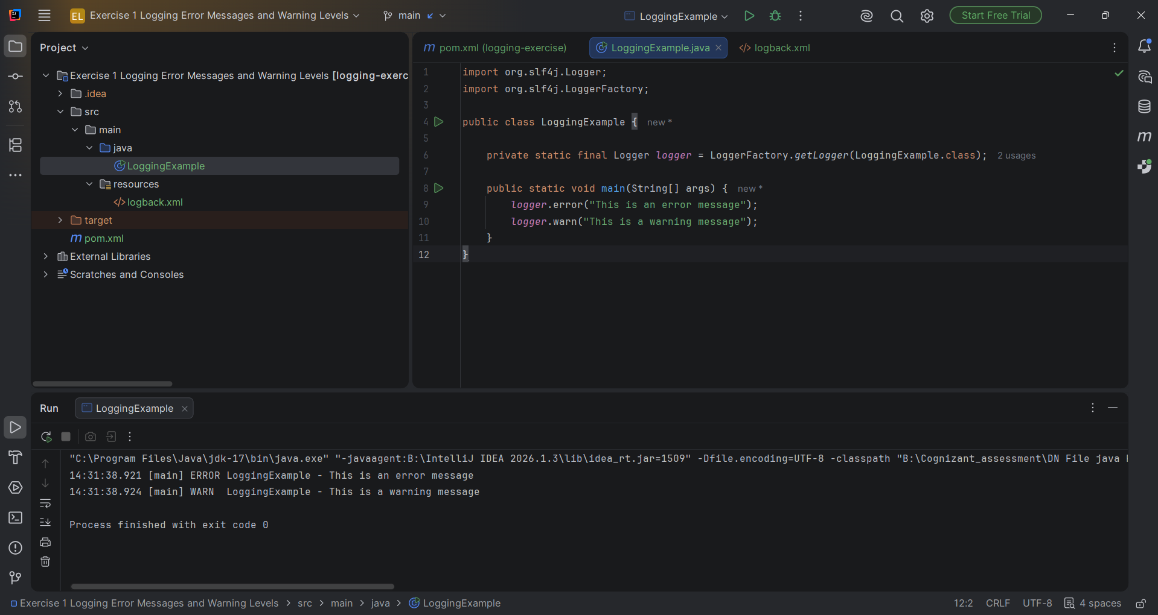
Figure 1: IntelliJ IDEA project view showing LoggingExample.java and the console output.

Result
Running the program produced the following two lines in the console, confirming that both the ERROR and WARN log levels were triggered correctly:
14:31:38.921 [main] ERROR LoggingExample - This is an error message
14:31:38.924 [main] WARN LoggingExample - This is a warning message

Process finished with exit code 0

Conclusion
This exercise showed how to bring SLF4J and Logback into a Maven project, obtain a Logger for a class, and emit messages at different severity levels. The ERROR line indicates a serious problem, while the WARN line indicates something worth noticing but not necessarily fatal. The console output confirms both levels are configured and working as expected.

